COMP 3270 FALL 2017
Programming Project: Autocomplete

Name: ____Garrett Blackmon_________ Date Submitted: __11/14/17___

1. Pseudocode: Understand the strategy provided for TrieAutoComplete. State the algorithm for the functions precisely using numbered steps that follow the pseudocode conventions that we use. Provide an approximate efficiency analysis by filling the table given below, for your algorithm.

Add
- Pseudocode:
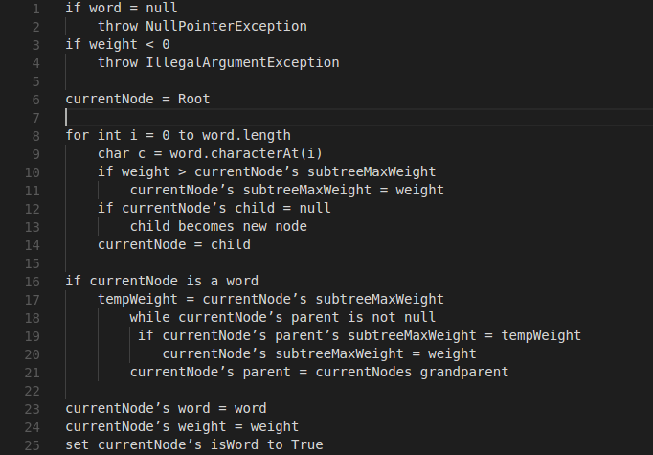

- Complexity analysis:

Complexity of the algorithm= O(_n_)

topMatch
- Pseudocode:
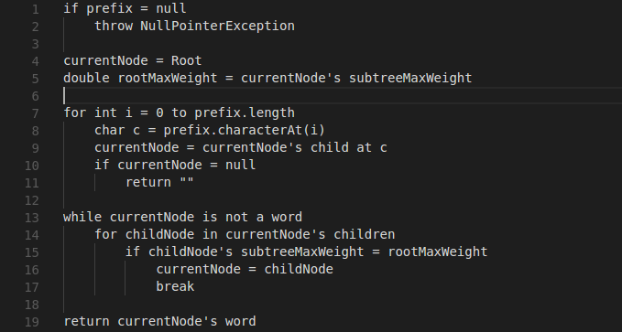

- Complexity analysis:

Complexity of the algorithm = O(_n²_)

topMatches
- Pseudocode: Complexity analysis:
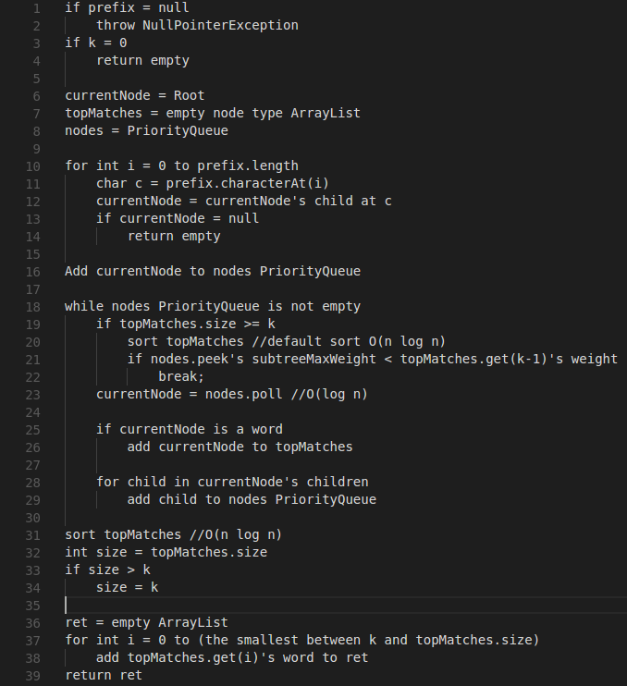

- Complexity of the algorithm = O(_n Log n_)

2.Testing: Complete your test cases to test the TrieAutoComplete functions based upon the criteria mentioned below.

Test of correctness:
Assuming the trie already contains the terms {”ape, 6”, ”app, 4”, ”ban, 2”, ”bat, 3”, ”bee, 5”, ”car, 7”, ”cat, 1”}, you would expect results based on the following table:
Query | k | Result
”” | - | Car
”a” | - | Ape
”ap” | - | Ape
”b” | - | Bee
”ba” | - | Bat
”c” | - | Car
”ca” | - | Car
”cat” | - | Cat
”d” | - | ””
” ” | - | ””
”” | 8 | {”car”, ”ape”, ”bee”, ”app”, ”bat”, ”ban”, ”cat”}
”” | 1 | {”car”}
”” | 2 | {”car”, ”ape”}
”” | 3 | {”car”, ”ape”, ”bee”}
”a” | 1 | {”ape”}
”ap” | 1 | {”ape”}
”b” | 2 | {”bee”, ”bat”}
”ba” | 2 | {”bee”, ”bat”}
”d” | 100 | {}

3.Analysis: Answer the following questions. Use data wherever possible to justify your answers, and keep explanations brief but accurate:
- What is the order of growth (big-Oh) of the number of compares (in the worst case) that each of the operations in the Autocompletor data type make?
- How does the runtime of topMatches() vary with k, assuming a fixed prefix and set of terms? Provide answers for BruteAutocomplete and TrieAutocomplete. Justify your answer, with both data and algorithmic analysis.
- How does increasing the size of the source and increasing the size of the prefix argument affect the runtime of topMatch and topMatches? (Tip: Benchmark each implementation using fourletterwords.txt, which has all four-letter combinations from aaaa to zzzz, and fourletterwordshalf.txt, which has all four-letter word combinations from aaaa to mzzz. These datasets provide a very clean distribution of words and an exact 1-to-2 ratio of words in source files.)
Benchmark: fourletterwordshalf.txt
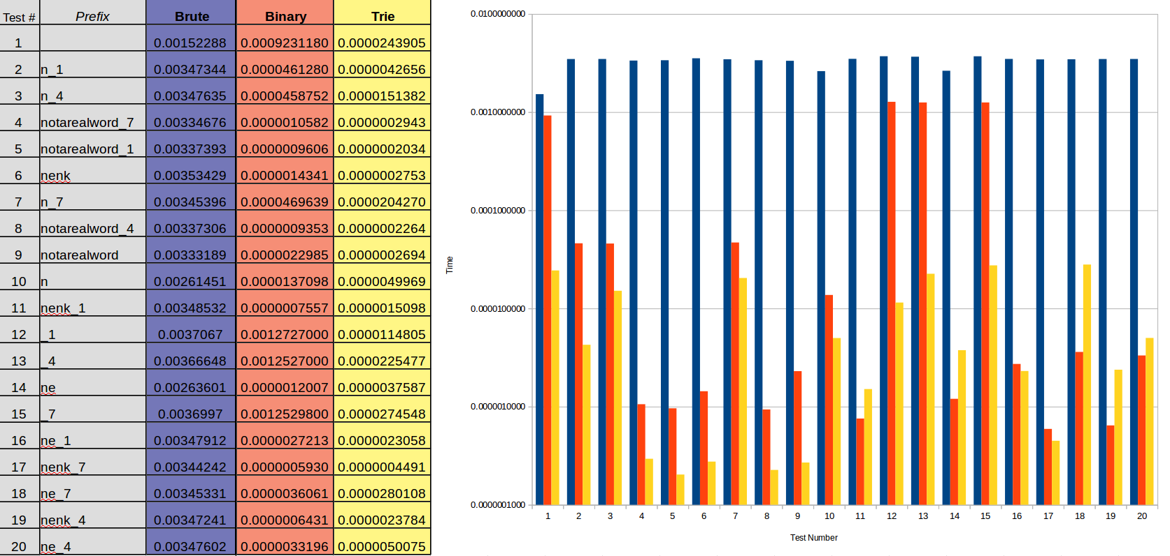
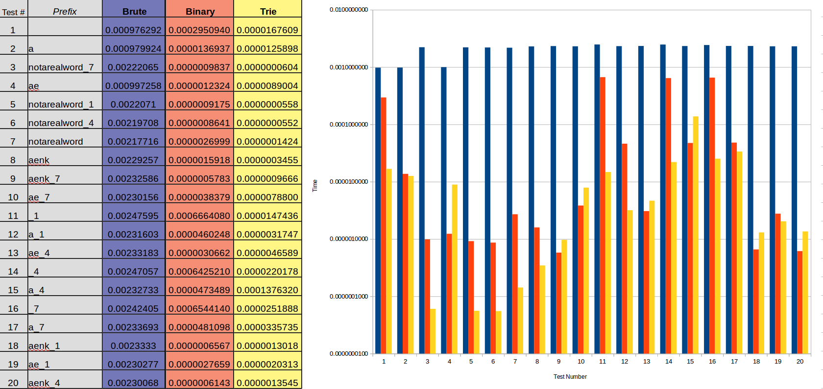
Benchmark: fourletterwords.txt

4. Graphical Analysis: Provide a graphical analysis by comparing the following:
- The big-Oh for TrieAutoComplete after analyzing the pseudocode and big-Oh for TrieAutoComplete after the implementation.

Compare the TrieAutoComplete with BruteAutoComplete.

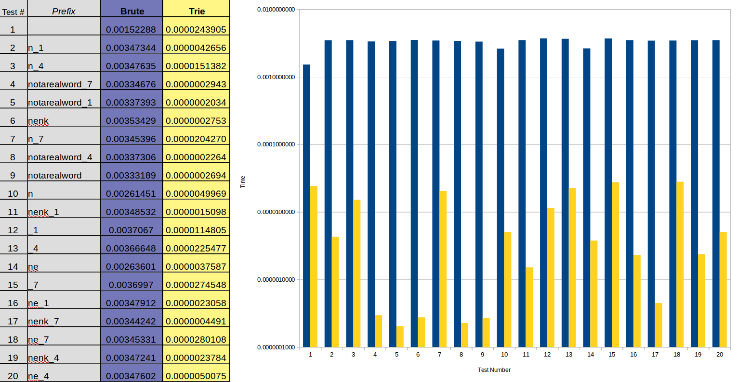
Benchmark: fourletterwords.txt

